EIE Department - ISTE STUDENT CHAPTER (2015-16) ODD
On behalf of the ISTE student chapter, every semester we are organizing technical and non-technical events for students. We emphasis the students to participate in ISTE events which may help them to shine in different platform. Nearly 25 events were conducted as on for the past three years. ISTE student chapter chairperson and secretary are nominated from IV year and representatives are selected for every class on the basis of their involvement in professional body activities.
ISTE REPRESENTATIVES
STUDENT CHAIR PERSON  MIRUNALINI.R |  | 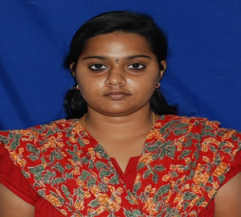
STUDENT SECRETARY  AHAMED FAYAZ.M |  | 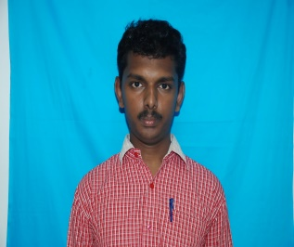
STUDENT REPRESENTATIVES |  | 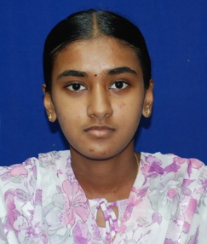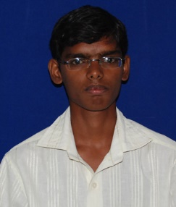
- Sneha lakshmi.J.K  - R.Siva Rama Krishnan | IV
- Sundara Malesh.M  - Kanmani.G | III | 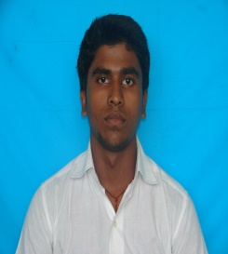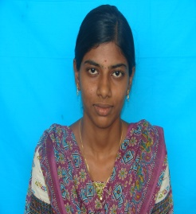
- Soundarya.K  - Aravinda manickam.K | II | 